Manual for the Kitchen Responsible

Summer 2024

Welcome as the kitchen responsible for a week at the Femø Women's Camp.

Being the kitchen responsible means it is your duty to…

- Ensure there are enough ingredients in the camp to be used throughout the day for the entire week!
- Keep track of: what do we need - what do we have - what are we missing
- Minimize food and ingredient waste
- Assist the cooking teams in starting food preparation
- Keep the kitchen tent organized both inside and outside including the dishwashing area.
- Keep track of the number of meat eaters, vegetarians, vegans, and Femønists/children with special diets/allergies
- Calculate and order food for your own week (Tuesday-Saturday)
- Calculate and order food for the next week until Tuesday morning, including coordinating with the next week regarding whether the week will be vegetarian or not
- Transfer information to the next week's kitchen responsible.

If you want BRUNCH, you must order it yourself on Sunday for delivery on Monday.
Different weeks hold brunch at different times.

Happy working!

Content
♀ General Information 3
Camp Phone: 30 22 06 65 3
Kitchen Layout and Functions 3
Rules 3
Freezer Elements 3
Gas 3
Introduction for Cooking Teams 3
Start Time 3
Introduction to the Recipes 4
NEW 4
Hygiene Rules 4
♀ Duties of the Kitchen Responsible 4
Presentation of the Role 4
Ordering Goods 5
Meal Plan for the weeks 6
Ensure that any leftovers are used for lunch. 7
Brunch 7
REMEMBER TO GIVE FEEDBACK TO DAGROFA – IN CASE OF COMPLAINT 7
Daily Tasks | Ordering Food | Collecting Food 8
Friday/Saturday Arrival 8
Every Day 8
Sunday 8
Monday 8
Wednesday 8
Thursday 9
Friday 9
Week List 9
♀ Sunday Ordering List 9
How to order 11
♀ Wednesday Ordering List 13
Freezing and Cooling in the Barn 13
Special Notes 13

♀ General Information

Camp Phone: 30 22 06 65

Kitchen Layout and Functions
The kitchen is set up according to its functions.
In the kitchen tent, the food items to be used during the day should be located. The tools’ tent is a storage area for non-perishables. The barn is for storing and cooling food, frozen items, and greens. In the kitchen tent, items should be kept in their designated places as much as possible.

There are instructions for cooking, coffee brewing, using ovens, dishwashing, hygiene, and more.
As the kitchen responsible, you must have the overview of the food items in different places and ensure they are used in the right order, i.e., oldest items first.
The kitchen responsible must create this overview themselves.

Rules
- Prevent accidents, mishaps, illness, and upset stomachs.
- Pay special attention to gas, fire, ovens, boiling water, coffee brewing, cigarettes, poor hygiene, old or perishable food items.
- We recommend ringing a bell for handwashing before handling food!

Freezer Elements
The camp’s freezers keep food cold with large freezer elements. These must be changed daily. The frozen elements are found in the barn's freezer. This task is shared with the truck responsible and possibly volunteers to carry the heavy elements. When the elements are taken out of the freezers, the boxes must be cleaned. Daily cleaning of the freezer boxes is part of the morning dishwashing team’s tasks.

Gas
Gas is used for the burners and the stove. The gas bottles are outside the kitchen tent. Keep an eye on the gas levels. The truck responsible collects the gas.

Introduction for Cooking Teams

Start Time
- Dinner takes about 3 hours to prepare.
- Lunch takes 1½ to 2 hours to prepare.
As the kitchen responsible, you must meet with the cooking team just before they start cooking.

Introduction to the Recipes
- Quantities. How many meat eaters, vegans, and vegetarians. All recipes are for 10 people. Adjust as needed throughout the week.
- Schedule. When is the food planned to be ready.
- Task Distribution: Break tasks into manageable projects. Who does what. Let the group distribute tasks themselves.
- Ensure continuous use of leftovers to minimize food waste.

- Remember to start by boiling water for potatoes etc.
- Remember hot water for dishwashing. Use all three large burners.

NEW
- All beans/chickpeas are now only available in canned form – we no longer need to soak them!
- Check if you need something for lunch. This year, we have created a new column in the ordering list indicating what is leftover and what is specifically ordered for breakfast/lunch.
- Hang a note with the number and types of allergies present during the week.
- Write on the list by the knife box if something is missing.

Hygiene Rules
- Use disinfectant soap.
- Wash hands:
- When you have touched soil, been in the toilet tent, wiped your nose/coughed, between handling meat and vegetables, etc.
- Start with a thorough cleaning of tables and cutting boards.

♀ Duties of the Kitchen Responsible

Presentation of the Role
There are usually two times when you as the kitchen responsible must present yourself, your role, and the kitchen.

- In the Presentation Round
- When the tour of the camp reaches the kitchen tent.

Presentation Round
In the presentation round, you can – in addition to personal information – say:

- The kitchen responsible is in charge of ensuring there are enough ingredients in the kitchen tent on time
- Changes to menus and larger spontaneous food activities must be agreed with the kitchen responsible
- Everyone can “grab a meal”
- Femønists/children with allergies or other special needs should come to you to figure out how to manage their allergies throughout the week
- Check if there are potential “morning bakers”
- You will introduce the cooking team a quarter of an hour before the start of cooking for lunch and dinner (arrange the time now or at the communal meeting)
We recommend ringing a bell for handwashing before handling food!!!

Tour of the Kitchen Tent
During the tour, you can explain:

- How the kitchen is divided into sections
- There are notes so everyone can find their way around during use and after washing up
- The area outside for pots and pans is only for those items
- Prevent accidents, e.g., children not being near the large burners
- How to use the fire extinguisher and fire blanket
- The gas system - the kitchen responsible can change the gas, but show how the system works
- How the coffee and tea system works
- Hygiene rules – read them and read them again…

Ordering Goods
One of your tasks is to order goods from Dagrofa for the upcoming week’s Saturday-Tuesday morning. Remember there are differences. Be aware that all weeks eat vegetarian meals in the evening except during Sports Week.

You must ensure there are goods for your own week (Tuesday-Friday) and for the next week (Saturday to Tuesday morning).

It is important that you as the Kitchen Responsible understand the system so your week gets the necessary ingredients for cooking. And so the next week gets the necessary ingredients for their cooking – without creating too much food waste. REMEMBER to check stock… cool/freeze/dry goods.

The last week(s) of the camp must be especially creative with leftover stock. If, for example, you have too much rye bread, it can be frozen and used later in the week.
In general, ensure that what has been ordered is used, preferably in an alternative way.

Most goods are ordered online from DAGROFA –
This means we can immediately see if the item is in stock and possibly choose an alternative.
Dagrofa delivers – Monday and Friday (possibly also Wednesday).
Orders for Monday – send Sunday and orders for Friday – send Wednesday. Both days preferably before 12.00 – but on Sunday, we can stretch it to 14.00 without panic – most items can be added until 23.00.

Special goods list – mostly vegan items ordered/reordered by Karen. Special items are ordered continuously by Karen. Expected reorder week 28 – and feel free to call/sms Karen at +45 28 62 66 28 – or email: kyjensen29a@gmail.com if you see we are running out of these items: Soy granulate, veg. mayo, veg. curry dressing, veg. burger dressing, yeast flakes, veg. cake mix, vegan spread nature and tomato spread, vegan pâté, various veg. spread and bean pâté, gluten-free falafel mix, and TOFU.

The growers on Femø, Christina Degnestrædet 11 – Phone: 60615170, are willing to deliver: potatoes, carrots, garlic, and herbs to us – they will come down to the camp or call and tell us what they can deliver – orders are made in connection with placing the order to Dagrofa (these items are also marked in green on the order list – and should of course only be ordered from Dagrofa if Christina cannot deliver).

Havnehøkeren
The Women's Camp does not have an account with the Havnehøker/ Grocer at the harbour. All purchases must be paid in cash or by card. Get any expenses covered by the economics responsible. In urgent cases, items can be bought but they have a very limited selection and in small quantities, so try to plan ahead.

Meal Plan for the weeks

The Women’s Camp meal plan contains fixed recipes for all days that are repeated every week. Most weeks only make vegetarian dishes for dinner.

In the evening, a vegan dish is made which can be supplemented with dairy products.
If the week has decided, also a main course with meat. For lunch, two to three dishes are made from the lunch inspiration section in the meal folder, supplemented with meat cold cuts and greens/fish. Remember to use the leftovers and place them at the front on the table.

Lunch inspiration is in the recipe folder – there is no fixed menu plan.

A picking list has been made. Fill it in with items for dinner and what is needed for lunch. They are available in paper format and can be taken to the barn.

Breakfast consists, in addition to various breakfast cereals, of bread which you can either order extra from Dagrofa or choose to bake yourself.

In the recipe folder, we have placed a bread recipe and an overview of which types of flour and grains have been ordered. If something is missing, more can be ordered from Dagrofa (see later).

Rye bread – there is a recipe in the recipe folder if you bake rye bread. If you bake rye bread, remember to reduce your order of rye bread. (You can possibly enter the number of rye bread you bake as stock items in the order list). Note that white beer is ordered as a stock item – only for rye bread – remember to use it and do not order extra.

Ensure that any leftovers are used for lunch.

Start the day by going through the "cool boxes" (the blue ones) in the kitchen tent and suggesting what they can be used for. Put a note in the meal folder with your suggestions. If there are many leftovers, use them first.

In the Lunch Inspiration (special recipes in the recipe folder), there are also ideas for using leftovers. Be aware of the number of vegans and the number of dishes!

If the necessary and agreed ingredients cannot be obtained, help the cooking team with alternatives. It may also be necessary to be creative with the recipes (read: stretch the food) if there are more people in the camp than calculated. Make sure there is plenty of rice/pasta/potatoes (boil extra potatoes if necessary) so no one goes to bed hungry (or to the communal meeting).

TIPS: Make a large batch of bean pâté, etc., and pack in smaller portions for several days! Chickpeas taste great roasted in a pan…

Brunch

If you need something that is not in stock for brunch, add the extra items you will need to the Sunday order. Inspiration for brunch can be found in the meal folder.

LAST BUT NOT LEAST…:

REMEMBER TO GIVE FEEDBACK TO DAGROFA – IN CASE OF COMPLAINT
- So we get a refund for bad or wrong items.
- Contact customer service via email or phone – the number is at the top of the order lists or on Dagrofa’s website.
- We cannot return items to Dagrofa – so check the stock thoroughly before ordering.
- Be aware that eggs, cheese, and butter are the expensive items…
- And remember that vegan butter must be in plastic containers.

NEW: we have reintroduced the stock list
CHECK STOCK… CHECK STOCK… CHECK STOCK

To help you, here is a “Weekly Plan for the Kitchen Responsible” where the main tasks for each day are listed.

Daily Tasks | Ordering Food | Collecting Food

Friday/Saturday Arrival
- You are welcome to arrange/bake a cake and make coffee for the welcome meeting on Saturday
- Quickly find a team for Saturday evening’s cooking.
- Christina comes down/calls and informs about what they can deliver.

Every Day
- Fill out the day’s “picking list” (what food items are needed for the day, what is in the camp, and what needs to be collected from the barn) – remember frozen meat for the next evening (the day after) must be taken out.
- Collect items from the barn for the next 24 hours (around 9:30 am)
- Get the cool boxes in the kitchen tent cleaned (morning dishwashing)
- Change cooling elements (truck responsible)
- Check if something needs soaking

Sunday
- Fill out the ordering list Sunday preferably before 12.00 – but on Sunday, we can stretch it to 14.00 without panic – most items can be added until 23.00.
Order goods list Sunday Online to Dagrofa before 14:00
Order items from Christina

Monday
- Goods are delivered for your week’s Monday to Saturday
Collect items from the ferry. The goods should be on the ferry at 10:35 am (sms from the driver when the trailer is ready)

Wednesday

- Check the number of participants for the next week’s camp and fill out the next week’s list
- Remember to check if the week is vegetarian for all evening meals.
- Contact the next week’s kitchen responsible if possible.
Check stock in the barn, kitchen, and workshop tent. Take a paper list if needed.
Order goods on the Thursday order list Online to Dagrofa before 12:00.

Thursday
- Wash dishcloths (Can be a task for Thursday/Friday – arrange this with your week team)
- Clean and make space for the delivery (in the fridges in the barn) of goods on Friday

Friday

- Goods are delivered for the next week’s Saturday-Monday morning.
Collect items from the ferry. The goods should be on the morning ferry (sms from Dagrofa driver)

Week List

- Week lists for your own and next week are sent to the week responsible along with a food list before the week starts.
- These lists form the basis for the orders for the week’s days.

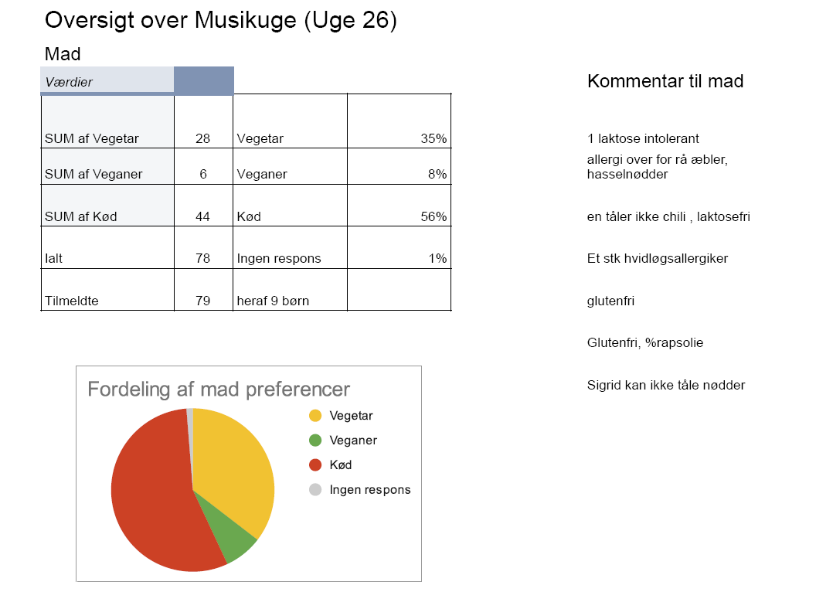

♀ Sunday Ordering List

For delivery on Monday
Sunday, order items for your own week for delivery on Monday (lunch up to and including Saturday / lunch pack including Brunch).

- To place the order, you need the number from your own week’s WEEK LIST.
- Note additional options regarding the Friday menu.
- On the calculation/order list set up on the camp PC with the week’s name, enter how many are registered for the upcoming week as vegetarians, vegans, meat-eaters, and children. Children are automatically counted as half a person.
- The light part ‘Calculations’ calculates the need and indicates the requirements.
- Also, make sure to enter your stock in the ‘in stock’ column. This will be automatically deducted…
- Then you assess based on the need and order unit how much you order and transfer these numbers to the paper copy.
- Use the paper copy to make your online order.
- Be aware of amounts over 1000 DKK – it may indicate an ordering error.
- Ordering is done online at www.dgfs.dk via the camp PC on Sunday (see detailed instructions below).

English translation of the fields below:
- Here you can check and adjust the delivery date – be aware of amounts over 1000 DKK – it may indicate an ordering error!
- Double-click on the favorites list and choose the desired list for your order.
- Double-click on the webshop and then Login.
- Username: 30164245 Password: Fe30164245

- Now you can see that all the items on your order list are here on the list and in the same order…
- You have a picture of the product.
- It will also show if you cannot order the item – and in that case, you can find an alternative.
- You can choose the quantity, usually there are 2 options but sometimes only one.

How to order

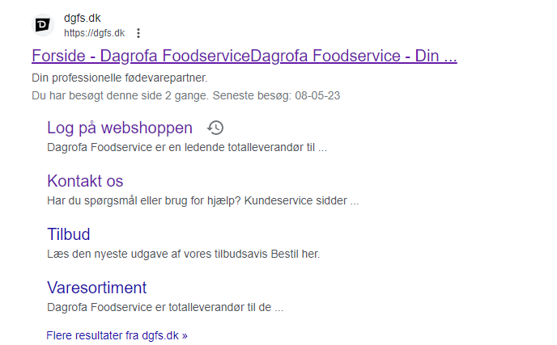
Dobbelklik på webshop og derefter på Login
Brugernavn er :30164245
Password Fe30164245

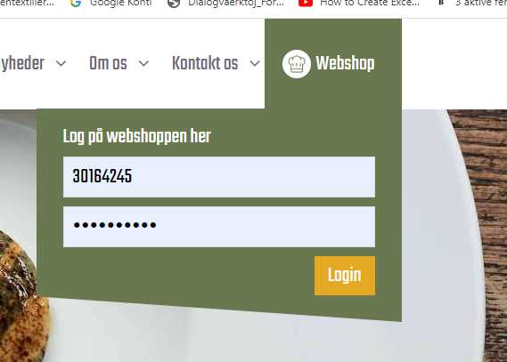
Her kan du tjekke og rette leveringsdato- vær opmærksom på beløb over 1000 kr – kan være en mængdefejl!

Dobbeltklik på favoritliste og vælg den ønskede liste til din bestilling

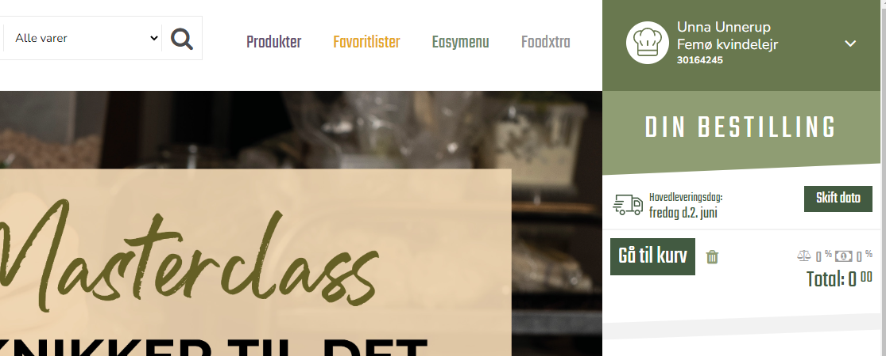

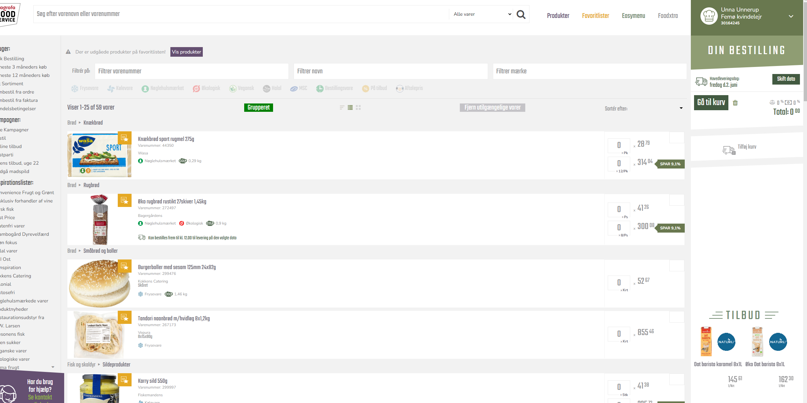
Nu kan du se at alle de varer på din bestillingsliste ligger her på listen og i samme rækkefølge…
Du har et billede af produktet
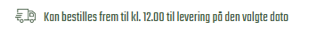Her vil det også fremgå hvis du ikke kan bestille varen – og i så fald kan du finde et alternativ.
Her kan du vælge antal der er oftest 2 muligheder, men nogle gange er der kun en mulighed

♀ Wednesday Ordering List

For delivery on Friday
Wednesday before 12, order items from Dagrofa for the next week’s Saturday evening to Tuesday morning.

- To place the order, you need the next week’s WEEK LIST.
- You fill it out with information from the week’s economics responsible or the Week responsible or possibly from the Secretariat.
- On the calculation/order list set up on the camp PC with the week’s name, enter how many are registered for the upcoming week as vegetarians, vegans, meat-eaters, and children. Children are automatically counted as half a person.
- The light part ‘Calculations’ calculates the need and indicates the requirements.
- Also, make sure to enter your stock in the ‘in stock’ column. This will be automatically deducted…
- Then you assess based on the need and order unit how much you order and transfer these numbers to the paper copy.
- Use the paper copy to make your online order.
- Ordering is done online at www.dgfs.dk via the camp PC (see detailed instructions above).

Dagrofa
- You must collect the items from the ferry. Items are expected in the morning – but there is always an sms from the driver when the trailer is ready – for return.
- A place for the trailer has been pre-booked on the ferry.
- The items must be transferred to the truck and immediately taken to the barn to be cooled and frozen.

Freezing and Cooling in the Barn
It is important to keep track of the items and the space in the barn. When new items arrive for the next week on Friday, make sure they go behind the current items and are kept separate from your week’s items. Use the opportunity to clear out what has become too old so everything is in order when the next responsible takes over.
Clean and organize the day before delivery.

Special Notes

- The last week(s) of the camp must be especially creative with leftover stock.
- Ensure that what has been ordered is used, preferably in an alternative way.
- CHECK STOCK… CHECK STOCK… CHECK STOCK
Remember to check the stock list for minimum stock both Sunday and Wednesday – it’s annoying to run out of pasta, rice, or similar.

